PLAN AHEAD AND REGISTER TODAY FOR FEBRUARY VACATION!
DEADLINE TO REGISTER IS FEBRUARY12. IF PROGRAMS DO NOT MEET THE MINIMUM # THE PROGRAM WILL BE CANCELED

WWW.WESTWOODREC.COM 781.461.0070

vacation art grades 2 -5
Thurston Middle School Cafeteria
Lisa Walker
Tue-Thu, Feb 19-21, 9:00-12:00
(Weather make-up day Fri, Feb 22)
$140 (3 classes) Min 6/Max 12

Calling all artists! If your child has a passion for creating things with their hands, these classes are a must! Students will create individual and group pieces in both 3D and 2D. 3D Art explores three dimensions while learning about carving, modeling and sculpture using recycled products, mixed media, clay and more. 2D Art explores the mark on a flat surface while learning about graphite, colored pencils, watercolor and more. No prior experience required. All supplies provided. Please provide snack and water bottle. Wear clothes that can get dirty. Looking to extend your day? See Full day option.

fun n’ Games grades k -6
Thurston Middle School Cafeteria
Recreation Staff
Tue-Thu, Feb 19-21, 9:00-12:00
(Weather make-up day Fri, Feb 22)
$70 (3 classes) Min 12/Max 40

It’s fast moving fun with a variety of sports and games activities including basketball, soccer, dodgeball, wacky relay races, capture the flag and more. There will be contests and tournaments with fun prizes. Talk it up with your friends; let’s have a blast during vacation!
Participants need to bring a peanut/nut free snack and water bottle. Sneakers required. Looking to extend your day? See Full day option.

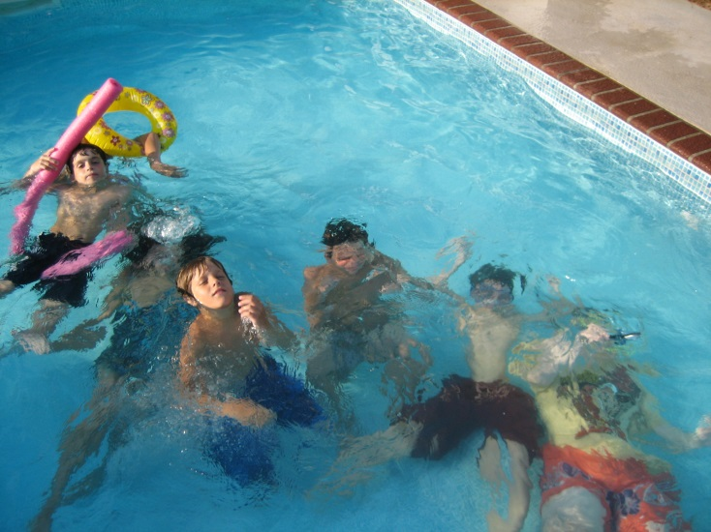

Lunch n’ pool grades k -6
Participants must be able to swim independently
Westwood Pool and Pool Lobby
Aquatics and Recreation Staff
Tue-Thu, Feb 19-21, 12:00-3:00 (Weather make-up day Fri, Feb 22)
$140 (3 classes) Min 10/Max 25

Have lunch with friends and then jump in the pool for free play, water basketball, cannonballs, under water scavenger hunt and more. Lunch time and Trivia 12:00-1:15; Pool Time 1:15-2:30, Snack Time 2:30-3:00. Participants need to bring bathing suit, towel and food listed below. Parents are to pick up their children in the pool lobby by 3:00.

Day | Date | Provided | Participant Needs
Tue | Feb 19 | Ice Cream Sundae Snack | Lunch & Drink
Wed | Feb 20 | Hot Dog Lunch | Snack
Thu | Feb 21 | Pizza Lunch | Snack

FULL DAY OPTION
Looking for a full day of activities 9:00-3:00? Choose either Vacation Art Camp or Fun N’ Games from 9:00-12:00 and then sign up for Lunch N’ Pool for 12:00-3:00. Participants registered for a morning program at Thurston and registered for the Lunch N’ Pool program will be transported by Town of Westwood vehicles from Thurston School to the Westwood Pool.

Kids photoGRAPHY Workshop grades 3-5
Islington Community Center – Room F
Melanie Guerra
Tue-Thu, Feb 19-21, 9:00-10:30 AM
$195 (3 classes) Min 4/ Max 6

This will be a creative, fun-filled workshop where kids will learn about camera settings, composition, the importance of lighting, photographing motion and more. We will play some photography games, experiment with what we've learned and even learn a little bit about film photography and see a collection of old cameras and flashes! This will definitely be a "learn by doing" experience!
Kids can use any digital camera with settings ( CoolPix, PowerShot or other "point and shoot" or a mirrorless or a DSLR! Sorry, smart phone cameras won't work in this workshop), and access to a computer for downloading their work is preferable.

